Patient Name | SAMIM ANSARI | Patient ID | 072431/34
Age/D.O.B | 28 | Gender | M
Ref Doctor | NA | Date | 3 Aug 24
MRI Brain Plain and Contrast
History
Headache
Technique
T1W Sagittal, Dw- b0, b500, b1000,
T2W Axial, Flair Coronal.
Post contrast T1FS images
Observations
Poorly defined area of T2 hyperintensity, no diffusion restriction, heterogeneous FLAIR hyperintensity, no areas of GRE blooming within it, no appreciable contrast enhancement. Mild surrounding oedema seen. Overall measures 34 x 24 mm
No abnormal parenchymal or meningeal contrast enhancement seen.
No evidence of abnormal signal intensity or volume loss in the hippocampii.
The thalami, basal ganglia and internal capsules are normal on both sides.
The ventricles and sulci are normal for the age.
The pituitary gland, infundibulum and hypothalamus are normal for the age.
The posterior fossa shows normal cerebellum.
The medulla, pons and mid brain shows normal signals in all the sequences.
Both CP angles are clear. The basal cisterns are normal.
Normal flow void is seen in the major dural venous sinuses and arteries.
Visualized sinuses are normal.
Bones are normal.
Impression
- Poorly defined area of T2 hyperintensity, no diffusion restriction, heterogeneous FLAIR hyperintensity, no areas of GRE blooming within it, no appreciable contrast enhancement. Mild surrounding oedema seen -- consider MR spectroscopy to rule out neoplastic aetiology (d/d;: Gliotic area less likely).
Key Images
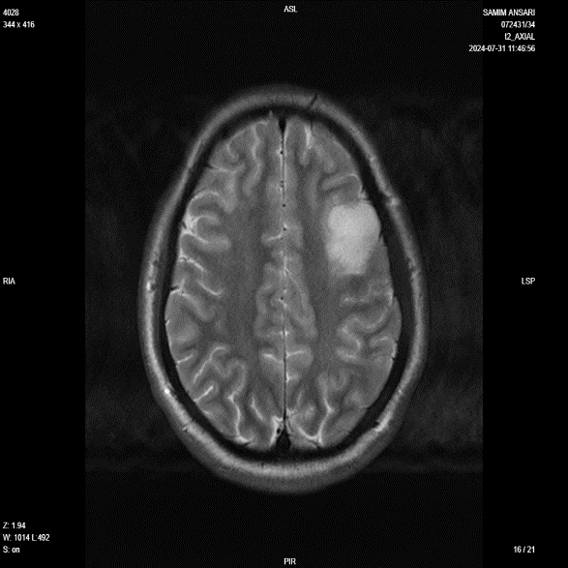
Image 1
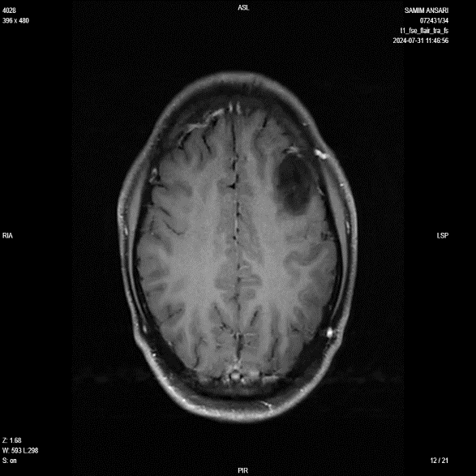
Image 2
Reported By,
Dr. Shashank G H
MBBS, MD, DNB
Consultant Radiologist
KMC - 118960
Disclaimer
This medical diagnostic report is generated based on the image and patient information obtained from the source of origin, 5C Network assumes no responsibility for errors or omission of or in the image, or in the contents of the report, which are a direct interpretation of the image sent from source. In no event shall 5C Network be liable for any special, direct, indirect, consequential, or incidental damages or any damages whatsoever, whether in an action of negligence or other tort, arising out of or in connection with the use of the 5C Network Service or the contents of the Service. This report does not replace professional medical advice, additional diagnoses, or treatment.
Kindly call Help Desk (+91-95872 74858) for any report related query.
Powered by 5C Network. All Rights Reserved.

